EXPERIMENT NO. 20

Creating a GitHub Repository and Implementing Version Control

Aim
To create a GitHub repository for a team project and implement version control using branches, pull requests, code reviews, conflict resolution, and workflow documentation.

Software Requirements
- Windows 10/11 (or Linux/macOS)
- Git
- GitHub Account
- Visual Studio Code (or any code editor)

Theory
Git is a distributed version control system that helps developers track changes and collaborate efficiently. GitHub provides a platform for hosting Git repositories and managing collaborative development. Developers work on separate branches, submit Pull Requests for review, resolve merge conflicts if necessary, and merge approved changes into the main branch. The project workflow is documented in the README file for better understanding and maintenance.

Procedure
Step 1: Create a GitHub Repository
- Log in to GitHub.
- Click New Repository.
- Enter the repository name.
- Select Public or Private.
- Click Create Repository.
Step 2: Clone the Repository
Open Git Bash or Terminal.
git clone https://github.com/YourUsername/RepositoryName.git

Move into the project folder.
cd RepositoryName

Step 3: Create Branches for Individual Modules
Create separate branches for different modules.
git checkout -b login-module

git checkout main
git checkout -b dashboard-module

Verify the branches.
git branch
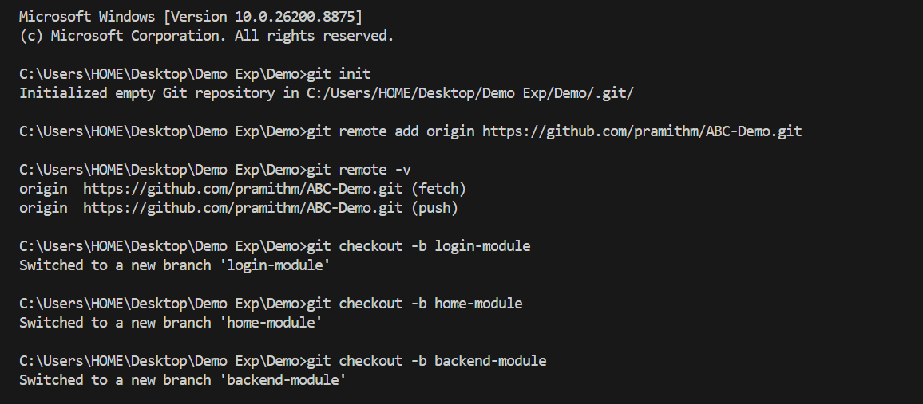
Step 4: Make Changes
- Open the project in Visual Studio Code.
- Implement the assigned module or update project files.
- Save the changes.
Step 5: Commit the Changes
Check the repository status.
git status

Stage the files.
git add .

Commit the changes.
git commit -m "Implemented login module"

Step 6: Push the Branch
git push origin login-module

Repeat the same process for other module branches.
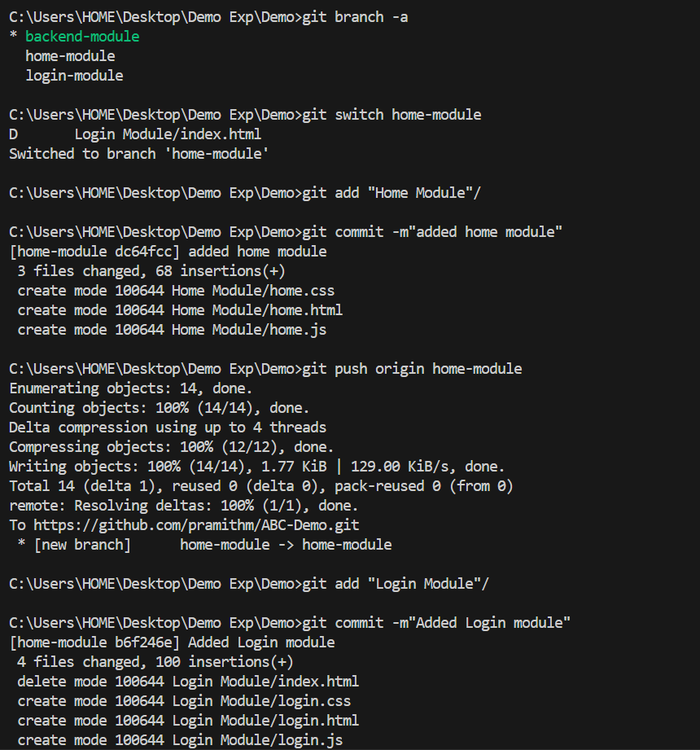

Step 7: Create a Pull Request
- Open the repository on GitHub.
- Select the pushed branch.
- Click Compare & Pull Request.
- Enter a title and description.
- Click Create Pull Request.
Step 8: Review the Pull Request
- Review the code changes.
- Add comments or suggestions if required.
- Approve the Pull Request after review.
Step 9: Resolve Merge Conflicts
If Git reports a merge conflict:
- Open the conflicting file.
- Remove the conflict markers.
- Keep the correct code.
- Save the file.
Stage the resolved file.
git add .

Commit the resolved merge.
git commit -m "Resolved merge conflict"
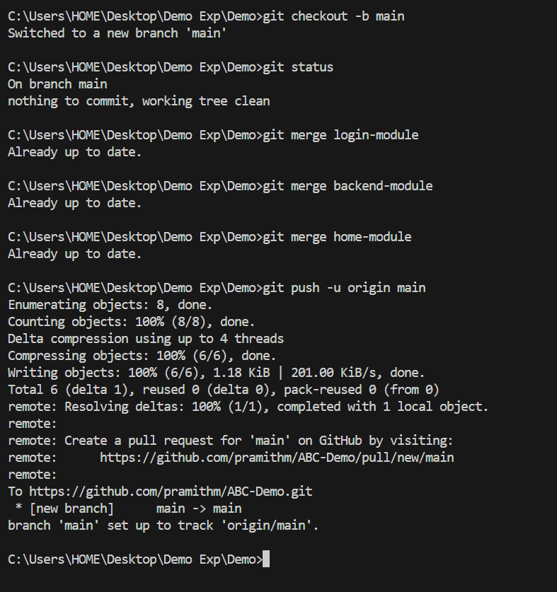
Step 10: Merge the Pull Request
- Click Merge Pull Request.
- Confirm the merge.
- Delete the merged branch if required.

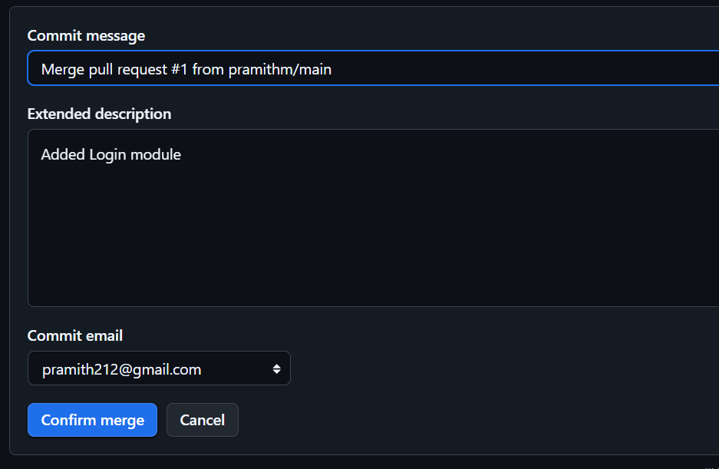
Step 11: Document the Workflow
Update the README.md file with:
- Project description
- Repository structure
- Branching strategy
- Steps to contribute
- Pull Request workflow
Commit and push the updated README.
git add README.md
git commit -m "Updated README with project workflow"
git push origin main

Step 12: Submit the Repository Link
Copy the GitHub repository URL and submit it. Example:
https://github.com/pramithm/ABC-Demo

Screenshots
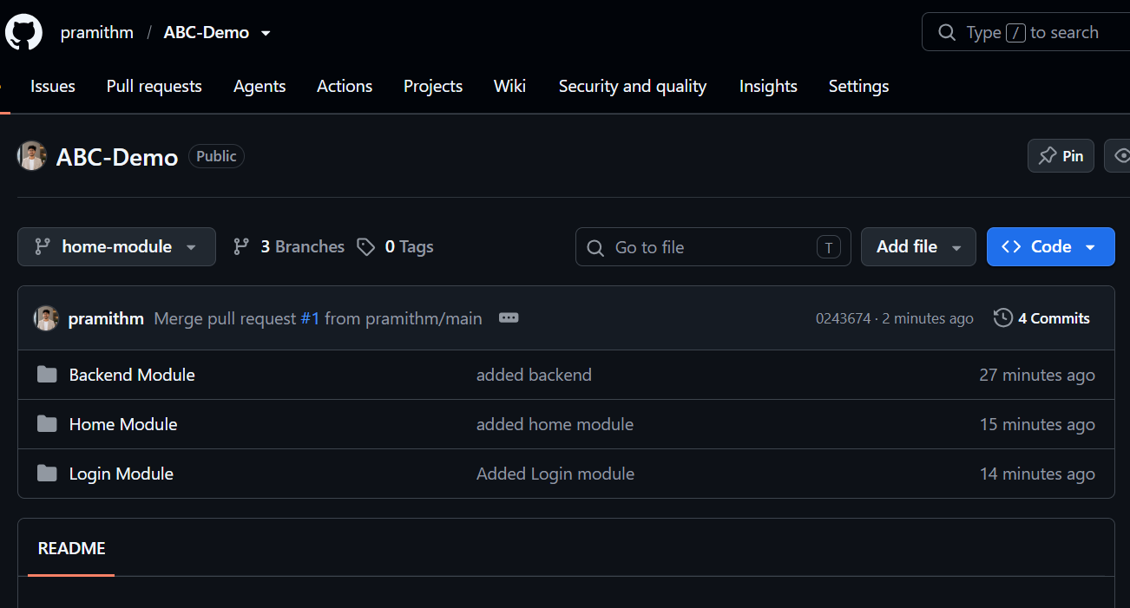

Observation
- GitHub repository was created successfully.
- Separate branches were created for different modules.
- Changes were committed and pushed successfully.
- Pull Requests were created and reviewed.
- Merge conflicts were resolved successfully.
- README file was updated with the project workflow.
- Repository link was generated successfully.

Result
The GitHub repository was successfully created, and version control was implemented using Git. Branches were created for individual modules, changes were reviewed through Pull Requests, merge conflicts were resolved, the workflow was documented in the README file, and the repository was successfully maintained using collaborative development practices.

